**CS 6314.0U2 Practice Work - 6**

**Due Date:** June 26, 2017, 10pm

Create following form on your index.html page.

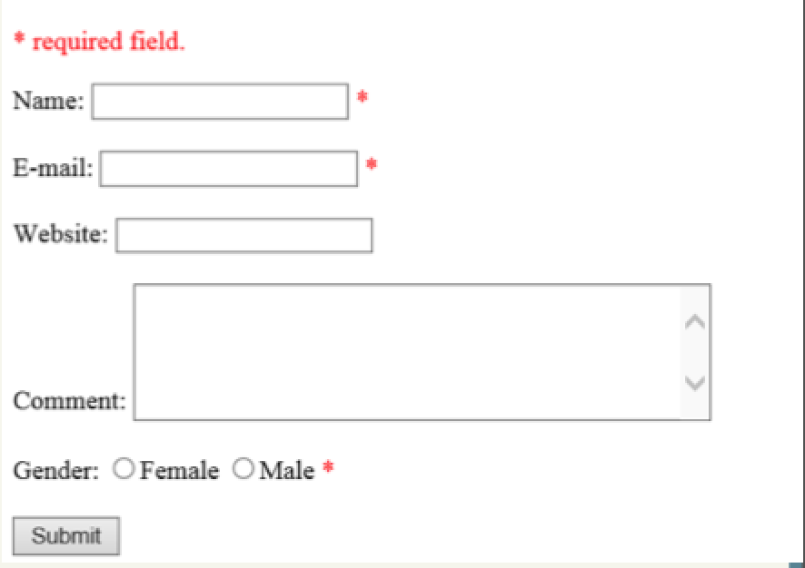

Read the form input and display it in comments.php.